 | Hung Vuong Aptech  Education | 

Auto Ancillaries Limited

Development’s Guide

Faculty: Nguyen Xuan Doan
BATCH: T01
GROUP CODE: G.S4-E-02
STUDENTS:
No | Full Name | Roll No
1 | Huynh Quoc Thanh | VN.040/200708/0018
2 | Tang Vi Nguyen | VN.040/200708/0025
3 | Le Dang Minh | VN.040/200710/0102
Table of Contents
1) Introduction 4
2) Existing Scenario 5
3) Customer Requirement Specification 7
4) Functional Requirement Specification 9
5) System Requirements 13
6) Development Software 13
7) Technology 13
8) Review 1 Task Sheet 14
9) Use Case and Sequence Diagram 16
10) Entity and Entity Relationship diagram (ERD) 52
11) Review 2 Task Sheet 56

REVIEW 1

Introduction
Auto Ancillaries Limited (AAL) is in the business of manufacturing important ancillaries for the two-wheeler and four-wheeler automobile industry. For the past few months they have been facing problems with their current system. Due to the problems they have felt the need for a change in their system. For this purpose, they have approached you to develop products. They would like you to study the problem at hand, and evolve a strategy for solving the current problems. In addition to this, they also want you to suggest solutions using which the company will get an added competitive edge in this cut-throat competitive market.

The diagram given below in Figure 1 shows the interrelationship of various departments of the AAL and its customers in relation to the "Invoicing and finished goods handling" system, the scope of the project.

Management

Factory
Dispatch Department

Other Warehouse

Invoicing & Finished goods handling
Order Processing department

Dealer

Quality Control

HO

Production Department

Direct Customer (OEM)
Store Keeper

Figure 1.The interrelationship of various departments of the AAL

Existing Scenario
AAL has an annual turnover of $ 15 million. The company has 4 factories and 4 warehouses. The clients of AAL are Original Equipment Manufacturer (OEM). The company reaches to the customer through dealers. A distribution set up for AAL is as follows:
Auto Ancillaries Limited
Factories.
Factories
Factories
Factories
W
W
W
W
Dealers

W – Ware Houses

Figure 2.Auto Ancillaries Limited Organizational Structure

The Ware Houses dispatch the orders directly to the OEMs and other customers. There are two types of dealers – Regular dealers and Exclusive dealers.

Regular dealers are the general dealers for other companies as well as for AAL’s products. Exclusive dealers cater only to the AAL’s product line. The company is thus required to have an elaborate system in place wherein all customers receive material without any delay and the dealers are updated with their stocks.

Presently the company is facing the following problems:

- There is no automation involved to speed up the distribution process or any other business process.
- Credibility with customers seems to be declining recently due to slip-ups on customer order processing and dispatches.
- Finished goods stock is not being managed properly and holding costs are high.
- Difficulties in communication and updating data due to distributed set up.
- Maintaining stocks at ware houses
- Preparing Invoices as well as dispatching the related documents and routing them to relevant departments or locations.
- Calculating discounts and other taxes and levies
- Delivering material in time
- Categorizing items as Fast or Slow moving while controlling inventory
- Prioritizing orders based on customers requirement and distance
- Increasing material rejection from customers
- Discrepancy between ordered and invoiced quantities due to either partial availability of stocks or due to clerical oversights.
- Insufficient checks in the current system for ensuring customer credit limits are not exceeded.
- Analyzing sales data to streamline production volumes.

Customer Requirement Specification
A system needs to be established which takes care of inventories, preparing invoices, categorizing goods based on consumption pattern, tracking payments from the customers, tracking the consignment, generating material rejection reports. The system also requires connecting warehouse servers to the server of the manufacturing plant, furnishing the warehouses with the necessary information, allow clients to view the current status of production and stocks at warehouses.

The system has to be hosted on the Web. The firms will have different discounts for customers based on their payment records. Each customer has accounts for logging into the system and is eligible to query about the production status. There would be an authentication process, which would enable the system to recognize the members or customers. The system should enable the members or customers to do the following:

Non-Financial:
- The account will primarily maintain the history of the members / customers in terms of the details of all the transaction made by the customers with the manufacturing firm.
- The customer should be able to place orders over the system. Once an order is placed the system should generate the invoice for the same. His payables should then be made available to him, taking into account his rating as a distributor. The customer system should host the inventory levels of the Warehouses and on the request of the customer, the server should be able to access this and inform the member or customer on his Economic Order Quantity (EOQ), Re-order point, time for placing the next order etc.
- The Customers, depending on his ratings would, have the option of viewing the Finished Goods inventory levels of the manufacturing unit.
- The Warehouse server data can be updated as soon as manufacturing unit update the current production.
- The Warehouse accepts the orders in a predefined format from customers through mails, faxes, web sites.
- Warehouses should be able to track material rejections. System should generate material rejection report.
- Central Inventory control system must keep a track of the material consumption and based on that should be able to categorize fast moving or slow moving, regular or seasonal goods.

Financials:
Billings for each order has to be done by the system and credited to the customers account. The system should be able to provide each customer with his current financial position in terms of details of payment made, outstanding and his rating as a customer with the company. The rating as a customer would be dependent on the volumes of purchase by them, his history as a defaulter etc. This in turn would determine his credit limit, entitlement to discounts, other benefits.

All the above facilities should be made available to the member or the customer as per his query, i.e. the customer may want to know all his outstanding balances and the system should provide him with his figures by extracting data from all the firms.

Functional Requirement Specification

Customer Requirements | Description | Functional Requirements
Guest can register. | The system must provide a page to allow guest create their accounts with the following information:  - User Name  - Password  - Name  - Birthday  - Address  - Phone  - Email | - User must provide Username, Password, Name, Birthday, Address, Phone, Email to create an account.  - Email must be valid, username and password must be from 6 to 12 characters.
Guest can  login. | The system must provide a page to allow guest login. | - Customers must provide Username and Password to login into the website.  - Customers can only access to pages they have permission.
Guest can recovery password. | The system must provide a page to allow guest recovery password. | - Customers must provide Email address to recovery password.
Guest and customer can search. | System must provide a page to allow guests to search products.  Information customer must provide when search products:  - Name of product.  - Price of product.  - Categories of product. | Customer must provide name of product, price of product, category of product to search. Customer can view the history of orders  - Description  Customer can view history of orders. The history is displayed as grid with all orders which customer ordered. The grid shows an action or information depend on current status of order. The status of an order must follow these steps:  + Customer places an order.  + If there is enough quantity of products, the status will be pending. The order is created, provides customer Invoices details.  + After that, the order’s status will be delivered, accepted or declined depend on administrator.  - Functional Requirement  - System displays the history of orders as grid form.  - System displays the status of individual orders.  - System provides action as link form for customer.
Customer can purchase an order. | Customer can purchase order. Modify the quantity of a product. The system will calculate the total price of order. | - The system must provide shopping cart page.  - Customer can modify the quantity of individual product in order.  - The system must calculate and display the total price of order.
Customer can view his/her profile. | Customer can view his/her profile. In where, he/she can change password and his/her personal information. | - The system must provide profile page.  - The profile page must provide change password function.  - The profile page must provide change personal information function.
Administrator can manage products. | System should provide for Administrators a page which allows they manage Products, view list of Products, search products by name, category, and price. | - Administrators can view list of products.  - Administrators can search products.  - Administrators can add new products.  - Administrators can update products.
Administrators can manage categories. | System should provide for Administrators a page which allows they manage categories. | - Administrators can view list of categories.  - Administrators can add new categories.
Administrators can search orders. | System should provide for administrators a page which allows they search orders with queries such as: all orders are delivered on current time, all orders are placed on specify time, all orders are queued on current time. | - Administrators can search all orders are delivered on current time.  - Administrators can search all orders are placed on specify time.  - Administrators can search all orders are queued/ pending on current time.
Administrators can manage accounts. | System should provide for Administrators a page which allows they manage Customers as view list of customers, search customers by name, address, and phone. | - Administrators can search all orders are delivered on current time.  - Administrators can search all orders are placed on specify time.  - Administrators can search all orders are queued/ pending on current time.
Administrators can accept or decline the rejected materials. | System should provide for Administrators a page which allows they manage rejected materials. | - Administrators can search rejected materials.  - Administrators can update rejected materials.  - Administrators can add new rejected materials.
Administrators can accept or decline the rejected products. | System should provide for Administrators 2 button accept/decline for each order to manage rejection when have rejected orders. | - Administrators can accept rejected orders.  - Administrators can decline rejected orders
Administrator can change password. | System should provide for Administrators a page to change his password, Admin must be enter old password correctly before enter new password. | - Administrators can change his password.

System Requirements

Hardware

Web Server
Processor | Pentium IV or higher.
Memory | 512MB RAM or greater.
Modem/ADSL | Connecting to internet 24/24

Client
Processor | Pentium III or higher.
Memory | 64MB RAM or greater.
Monitor | Super VGA (800x600) or higher resolution with 256 colors.
Pointing Device | Standard mouse or compatible pointing device.
Modem/ADSL | Connecting to internet. 254Kb/s

Software

Web Server
Operation System | Windows XP
Browser | Internet Explorer 7.0 or higher.
Database | Microsoft SQL Server 2005
Software | Java SDK 1.6
Vendor | Jboss 4.2.3 GA

Client
Operation System | Windows XP or later.
Browser | Internet Explorer 6.0 or higher.

Development Software
- NetBeans 6.8
- Microsoft SQL Server 2005

Technology
- J2EE 1.4
- JSP , Servlet , EJB

Review 1 Task Sheet

No | Title | Start Date | Finish Date | Name
01 | Analysis | 01/07/2010 | 01/08/2010 | All of group

 | Prepared by (Student) | Approved by (Faculty)
Signature | Team leader | Nguyen Xuan Doan
Date | 9/7/2010 | 9/7/2010

REVIEW 2

Use Case and Sequence Diagram

- Guest

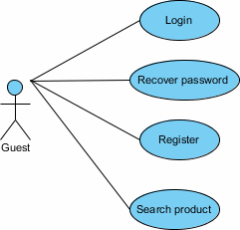

Figure 3.Guest Use Case

Register

Author | Huynh Quoc Thanh
Use Case Name | Register
Actor | Guest
Description | Guest wants to become a member.
Requirements | N/A
Pre-conditions | N/A
Post-conditions | Success: Member account is created.  Fail: Guest have to register again.
Basic flow | Actor action  1. Actor clicks register link in homepage.  3. After actor fills information, they submit the form by click “Register” button. | System responses  2. System navigates guest to register page and display register form with the following controls:  - “Username” text field.  - “Password” text field.  - “Confirm” password text field.  - “First name” text field.  - “Last name” text field.  - “Gender” radio.  - “Birthday” text field.  - “Email” text field.  - “Phone” text field.  - “Address” text field.  - “Country” combo box.  - “Secure code” text field.  - “Register” button.  4. System validates actor’s data.  5. Stores data into database and displays appropriate message to actor.
Alternative flow | Actor action  1. Actor clicks other link. | System responses  2. System cancels the register action and navigate actor to appropriate page.
Exception | Actor action  1. Actor lefts required filed blank.  2. Username already exists.  3. Username between 6 and 12 characters long.  4. Password between 6 and 12 characters long.  5. Confirm password must equal password field.  6. Birthday must in format dd-mm-yyyy.  7. Email must be valid. | System responses  System redirects to register form and displays error message.

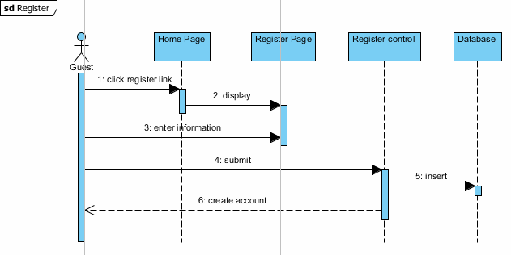

Figure 4.Register Sequence

Login

Author | Huynh Quoc Thanh
Use Case Name | Login
Actor | Guest
Description | Guest wants to use member function.
Requirements | N/A
Pre-conditions | N/A
Post-conditions | Success: Guest logged into website.  Fail: Guest have to login again.
Basic flow | Actor action  1. Actor clicks login link in homepage.  3. After actor fills information, they submit the form by click “Login” button. | System responses  2. System navigates guest to login page and display login form with the following controls:  - “Username” text field.  - “Password” text field.  - “Register” button.  - “Lost password” link.  - “Register” link.  4. System validates actor’s data.  5. Checks valid member and redirect to target page.
Alternative flow | Actor action  1. Actor clicks other link. | System responses  2. System cancels the login action and navigates actor to appropriate page.
Exception | Actor action  1. Actor lefts required filed blank. | System responses  System redirects to login form and displays error message.  1. No such member.  2. Member inactive.  3. Incorrect password.

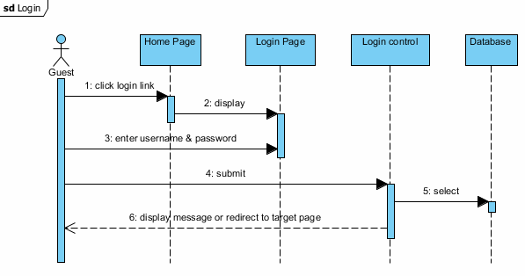

Figure 5.Login Sequence

Change Password

Author | Huynh Quoc Thanh
Use Case Name | Change password
Actor | Member
Description | Member wants to change their password.
Requirements | N/A
Pre-conditions | Authenticated user
Post-conditions | Success: Member has changed password.  Fail: Member have to change password again.
Basic flow | Actor action  1. Actor click change password link in profile page.  3. After actor fills information, they submit the form by click “Submit” button. | System responses  2. System navigates guest to change password page and display change password form with the following controls:  - “Old password” text field.  - “New password” text field.  - “Confirm password” text field.  - “Submit” button.  4. System validates actor’s data.  5. Checks valid member password then update new password.
Alternative flow | Actor action  1. Actor clicks other link. | System responses  2. System cancels the change password action and navigates actor to appropriate page.
Exception | Actor action  1. Actor lefts required filed blank.  2. Actor inputs password not between 6 and 12 characters long.  3. Actor inputs confirm password that does not match password. | System responses  System redirects to change password form and displays error message.  1. Invalid old password.

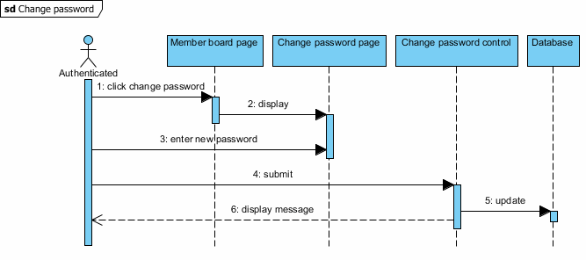

Figure 6.Change Password Sequence

Search Product
Author | Tang Vi Nguyen
Use Case Name | Search Product
Actor | Member
Description | Member wants to search the Ancillaries
Requirements | N/A
Pre-conditions | Authenticated user
Post-conditions | Success: System found the products  Fail: System can not find the products
Basic flow | Actor action  1. Actor click search product in the main page  3. After actor fills information, they submit the form by click “Submit” button. | System responses  2. System navigates guest to search product page and checks the information.  4. System displays result as form with grid that contains some control as:  - Image of the product.  - ‘ProducName’ label.  - ‘Price’ label.  - ‘Order’ link.  - ‘Detail’ link.
Alternative flow | Actor action  1. Actor clicks other link. | System responses  2. System cancels the search product action and navigates actor to appropriate page.
Exception | Actor action  1. Actor lefts required filed blank. | System responses  System redirects to page and displays error message.  1. Please fill all information.

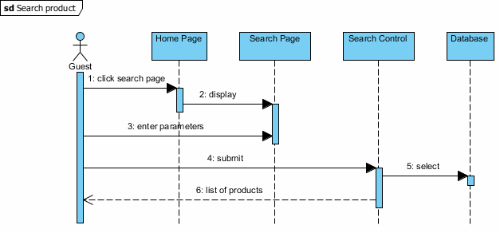

Figure 7.Search Product Sequence

- Dealer

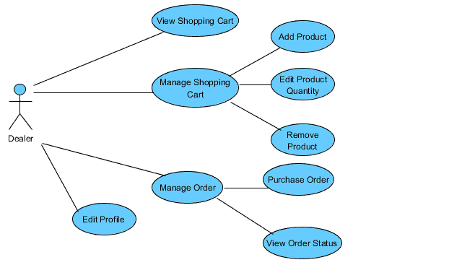

Figure 8.Dealer Use Case

- View Basket

Author | Le Dang Minh
Use Case Name | View Basket
Actor | Dealer
Description | Dealer wants to see their basket (shopping cart).
Requirements | N/A
Pre-conditions | Authenticated user
Post-conditions | Success: All product in basket will be shown  Fail: Error Message
Basic flow | Actor action  1. Actor clicks view basket in homepage. | System responses  2. System navigates actor to view basket page and display basket table with the following column:  - “name” of item.  - “brief” information of item  - “price” of item.  3. System load session of item which user added.  4. Display all item in basket .
Alternative flow | Actor action  1. Actor clicks other link. | System responses  2. System cancels the view basket action and navigate actor to appropriate page.
Exception | Actor action  1. Actor hasn’t added item into basket | System responses  1. System display empty table with a message “ You haven’t added any item into basket”
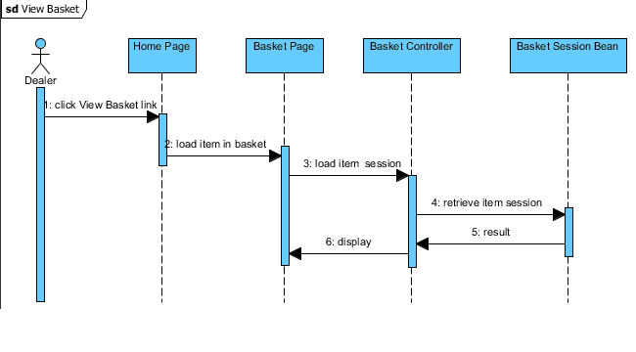

Figure 9.View Basket Sequence
- Add Product

Author | Le Dang Minh
Use Case Name | Add Product
Actor | Dealer
Description | Dealer add product into basket
Requirements | N/A
Pre-conditions | Authenticated user
Post-conditions | Success: Product will be added into basket  Fail: Display error message
Basic flow | Actor action  1. Actor clicks “add to basket” when he chooses one product in product page. | System responses  2. System stores item into session.  3. Send “Product has been added” message to actor.
Alternative flow | Actor action  1. Actor clicks other link. | System responses  2. System navigates actor to appropriate page.
Exception | Actor action  N/A | System responses  N/A

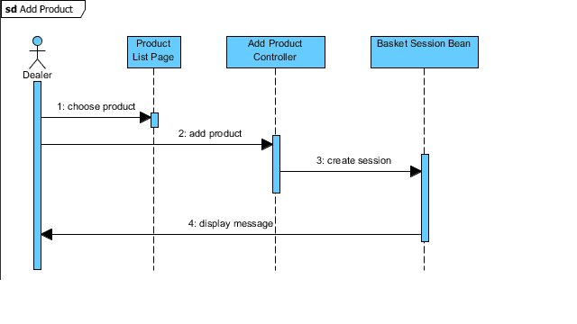

Figure 10.Add Product Sequence

- Edit Product

Author | Le Dang Minh
Use Case Name | Edit Product Quantity
Actor | Dealer
Description | Dealer want to change the quantity of product in basket
Requirements | N/A
Pre-conditions | Authenticated user
Post-conditions | Success: the quantity of product will be updated  Fail: Display error message
Basic flow | Actor action  1. Actor inputs number in “Quantity” text field . | System responses  2. System will check the quantity which actor inputs with the quantity in stock.  3. The number of quantity will be changed.
Alternative flow | Actor action  1. Actor clicks other link. | System responses  2. System navigates actor to appropriate page.
Exception | Actor action  1. The number which actor inputs is larger than the one in stock | System responses  1. System will send “The number is too large” message

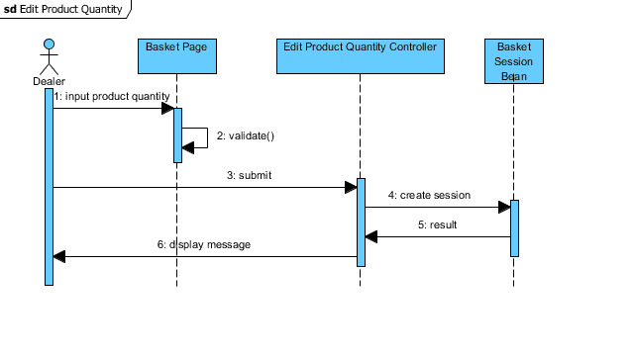

Figure 11.Edit Product Sequence

- Remove Product

Author | Le Dang Minh
Use Case Name | Remove Product
Actor | Dealer
Description | Dealer remove product from basket
Requirements | N/A
Pre-conditions | Authenticated user
Post-conditions | Success: Product will be removed from basket  Fail: Display error message
Basic flow | Actor action  1. Actor clicks “remove Product” when he chooses one product in basket.  3. Actor click “Yes” button | System responses  2. System asks actor to confirm this action.  4. Product will be removed from basket.
Alternative flow | Actor action  1. Actor clicks other link. | System responses  2. System navigates actor to appropriate page.
Exception | Actor action  N/A | System responses  N/A
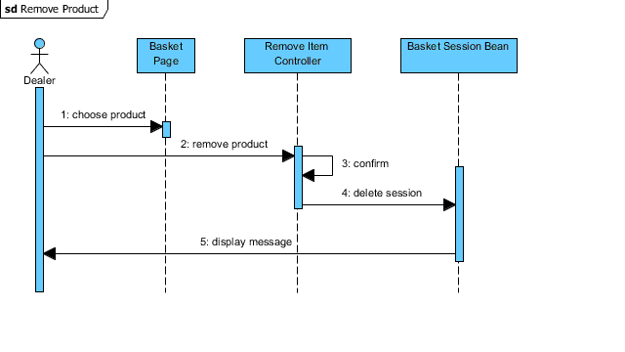

Figure 12.Remove Product Sequence

- Purchase Orders

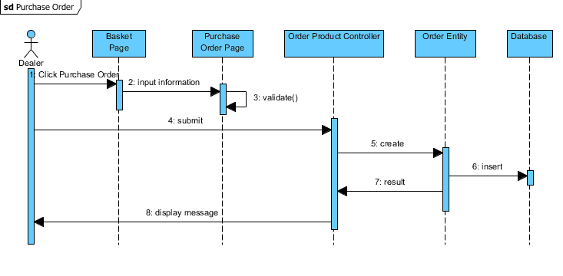

Figure 13.Purchase Orders Sequence

Author | Le Dang Minh
Use Case Name | Purchase Orders
Actor | Dealer
Description | Dealer wants to order product
Requirements | N/A
Pre-conditions | Authenticated user
Post-conditions | Success: Order will be sent to administrator  Fail: Dealer have to refill information again
Basic flow | Actor action  1. Actor click “order product” button in basket page.  3. After actor fills information, they submit the form by click “Submit” button. | System responses  2. System navigates actor to order product page and display order product form with the following controls:  - “Order Date” text field.  - “Require Date” text field.  - “Shipment Date” text field.  - “Shipment Address” text field.  - “Shipment City” text field.  - “Shipment Country” text field.  - “Submit” button.  *And specific detail for each item:  -“product name” label  - “quantity“ text field  - “price ” label  - “total” label  4. System validates actor’s data.  5. Create new order and send “ Order Product Successfully” message
Alternative flow | Actor action  1. Actor clicks other link. | System responses  2. System cancels the order product action and navigates actor to appropriate page.
Exception | Actor action  1. Actor lefts required filed blank. | System responses  System redirects to order product form and displays error message.

- View Order Status
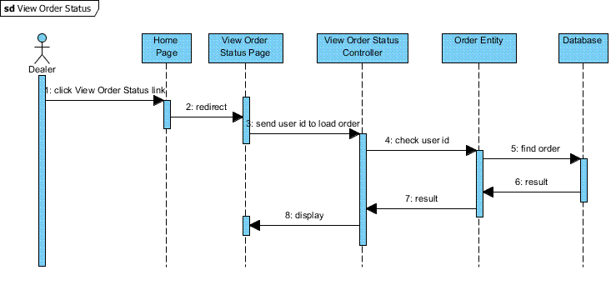

Figure 14.View Order Status Sequence

Author | Le Dang Minh
Use Case Name | View Order Status
Actor | Dealer
Description | Dealer view their order status (confirm, not confirm...)
Requirements | N/A
Pre-conditions | Authenticated user
Post-conditions | Success: all order of user will be display  Fail: Display error message
Basic flow | Actor action  1. Actor clicks “view order status” link on the home page | System responses  2. System navigates actor to view order status page and display order table with the following column :  - “Order Date”  - “Require Date”  - “Shipment Date”  - “Shipment Address”  - “Shipment City”  - “Shipment Country”  - “Total”  - “Status”  - “Approved”
Alternative flow | Actor action  1. Actor clicks other link. | System responses  2. System navigates actor to appropriate page.
Exception | Actor action  N/A | System responses  N/A

- Edit Profile

Author | Le Dang Minh
Use Case Name | Edit Profile
Actor | Dealer
Description | Dealer want to edit their profile
Requirements | N/A
Pre-conditions | Authenticated user
Post-conditions | Success: all information will be updated  Fail: Display error message
Basic flow | Actor action  1. Actor clicks “Edit Profile” link on the home page  3. Actor fill information and click “Update” button | System responses  2. System navigates actor to view edit profile page and display edit profile form with the following fields :  - “First Name”  - “Last Name”  - “Gender”  - “Birthday”  - “email”  - “phone”  - “address”  - “country”  4. System validate information  5. Update data into database and send “updated successfully message”.
Alternative flow | Actor action  1. Actor clicks other link. | System responses  2. System navigates actor to appropriate page.
Exception | Actor action  1. Actor lefts required filed blank.  2. Birthday must in format dd-mm-yyyy.  3. Email must be valid. | System responses  System redirects to register form and displays error message.

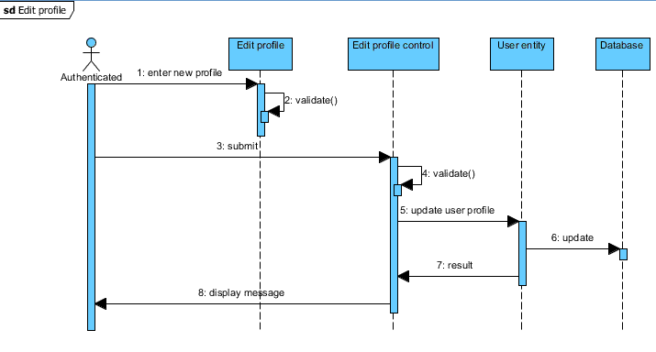

Figure 15.Edit Profile Sequence

- Administrator

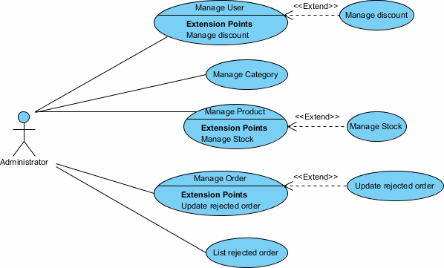

Figure 16.Administrator Use Case

- Manage User

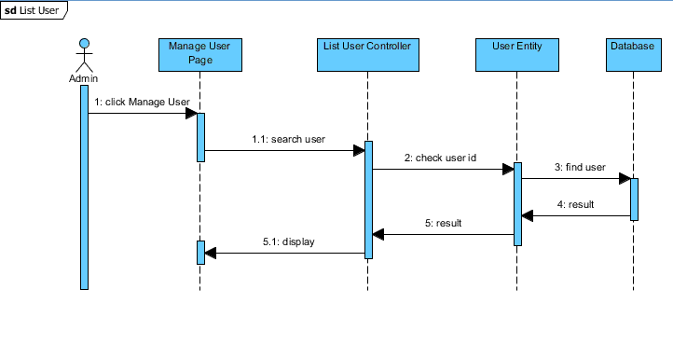

Figure 17.List User Sequence

Author | Tang Vi Nguyen
Use Case Name | Manage User Account
Actors | Administrator
Description | Administrator can view User Account list. Besides that, Administrator can search account, view account information.
Requirements | N/A
Pre-conditions | Actor has logged in as Administrator
Post-conditions | Success: All account will be show in data grid.
Basic flow | Actor Actions:  1. Actor clicks ‘Manage Account’ Link in Admin Home page.  3. Actor fills information in ‘txtSearch’ field and clicks ‘btnSearch’ button. | System Responses:  2. System redirects to Manage Account page and displays Manage Account form with grid that contains some following control as:  -‘txtSearch’ Label  -‘btnSearch’ button  -‘CusUsername’ Label  -‘CusAddress’ Label  -‘CusPhone’Label  - ‘Back to Home page’ Link  4. System checks search query, if query is blank, system direct to manage account page and don’t do any thing.  Else, System returns search result.
Alternative flow | Actor Actions:  1. ‘Back to Home page’ Link. | System Responses:  1. System redirect to admin home page.
Exception | N/A | N/A

- Manage Discount

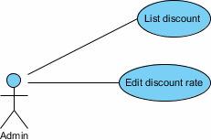

Figure 18.Manage Discount Use Case

- List Discount
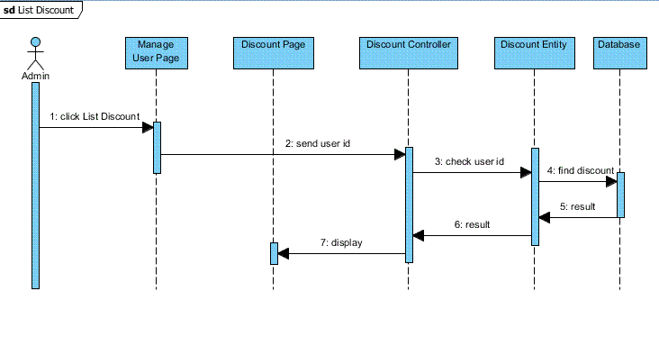

Figure 19.List Discount Sequence

Author | Tang Vi Nguyen
Use Case Name | List Discount
Actor | Administrator
Description | Administrator views list of discount
Requirements | N/A
Pre-conditions | Authenticated user
Post-conditions | Success: All discount will be shown  Fail: Error Message
Basic flow | Actor action  1. Actor clicks “List discount” on the Member User page | System responses  2. System navigates actor to view discount page and display discount table with the following column:  - “name” of item.  - “rate” of item
Alternative flow | Actor action  1. Actor clicks other link. | System responses  2. System navigates actor to appropriate page.
Exception | Actor action  N/A | System responses  1. N/A

- Edit Discount Rate
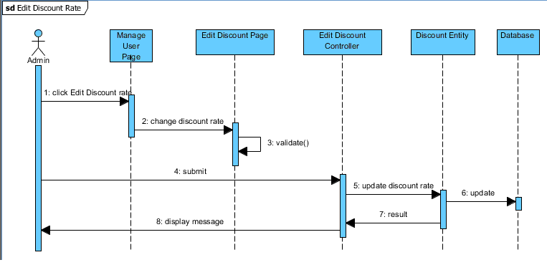

Figure 20.Edit Discount Rate Sequence

Author | Tang Vi Nguyen
Use Case Name | Edit Discount Rate
Actor | Administrator
Description | Administrator edit exist discount rate
Requirements | N/A
Pre-conditions | Authenticated user
Post-conditions | Success: Discount rate will be update to system  Fail: Display error message
Basic flow | Actor action  1. Actor clicks “Edit Discount Rate” link on manage user page  3. Actor edit information and click “Update” button | System responses  2. System navigates actor to edit discount page and display form with the following controls :  - “txtDiscountName” text field  - “txtDiscountRate” text field  4. System validate information  5. Add data into database and send “Update successfully message”.
Alternative flow | Actor action  1. Actor clicks other link. | System responses  2. System navigates actor to appropriate page.
Exception | Actor action  1. Actor lefts required filed blank. | System responses  System displays error message.

- Manage Category

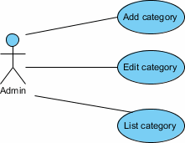

Figure 21.Manage Category Use Case

  - Add Category

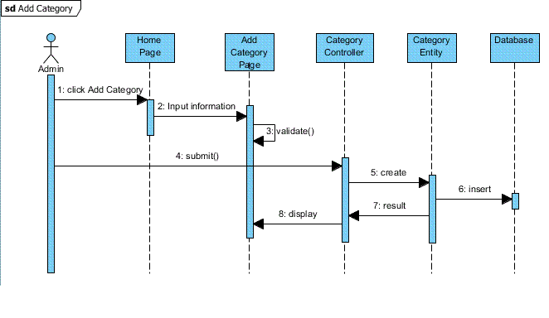

Figure 22.Add Category Sequence

Author | Tang Vi Nguyen
Use Case Name | Add Category
Actor | Administrator
Description | Administrator add new category into system
Requirements | N/A
Pre-conditions | Authenticated user
Post-conditions | Success: Category will be add to system  Fail: Display error message
Basic flow | Actor action  1. Actor clicks Add Category” link on main administrator page  3. Actor fill information and click “Add” button | System responses  2. System navigates actor to add category page and display “Add Category” form with the following controls :  - “txtCateName” text field  - “txtCateDescription” text field  4. System validate information  5. Add data into database and send “Add successfully message”.
Alternative flow | Actor action  1. Actor clicks other link. | System responses  2. System navigates actor to appropriate page.
Exception | Actor action  1. Actor lefts required filed blank. | System responses  System displays error message.

  - Edit Category

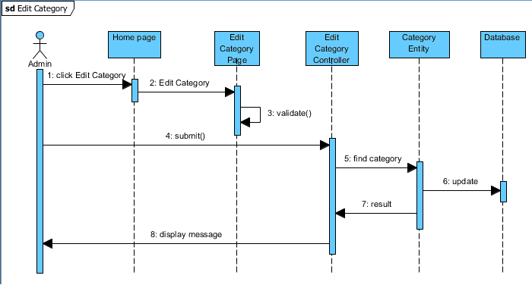

Figure 23.Edit Category Sequence

Author | Tang Vi Nguyen
Use Case Name | Edit Category
Actor | Administrator
Description | Administrator edit exist category
Requirements | N/A
Pre-conditions | Authenticated user
Post-conditions | Success: Category will be update to system  Fail: Display error message
Basic flow | Actor action  1. Actor clicks “Edit Category” link on sub menu Category. After actor chooses category which will be edit, clicks “Edit” icon.  3. Actor edit information and click “Update” button | System responses  2. System navigates actor to edit category page and display “Edit Category” form with the following controls :  - “txtCateName” text field  - “txtCateDescription” text field  4. System validate information  5. Add data into database and send “Update successfully message”.
Alternative flow | Actor action  1. Actor clicks other link. | System responses  2. System navigates actor to appropriate page.
Exception | Actor action  1. Actor lefts required filed blank. | System responses  System redirects to register form and displays error message.

  - List Category

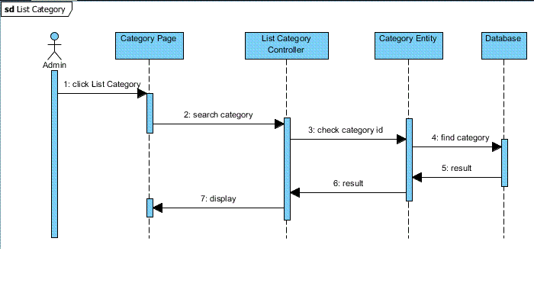

Figure 24.List Category Sequence

Author | Tang Vi Nguyen
Use Case Name | List Category
Actor | Administrator
Description | Administrator views list of category
Requirements | N/A
Pre-conditions | Authenticated user
Post-conditions | Success: All category will be shown  Fail: Error Message
Basic flow | Actor action  1. Actor clicks “List category” on the main administrator page  3. Actor fill category field if they want to search category and click “submit” buttion. | System responses  2. System navigates actor to view category page and display category table with the following column:  - “name” of item.  - “description” information of item  4. System displays result as form with grid that contains some control as:  - “Category Name” of item  - “Category Description” of item
Alternative flow | Actor action  1. Actor clicks other link. | System responses  2. System cancels the view basket action and navigate actor to appropriate page.
Exception | Actor action  1. Actor lefts required filed blank. | System responses  1. System redirects to register form and displays error message.

- Manage Product

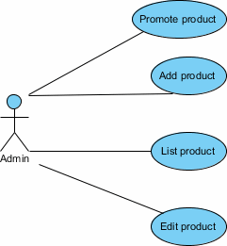

Figure 25.Manage Product Use Case

- Promote Product

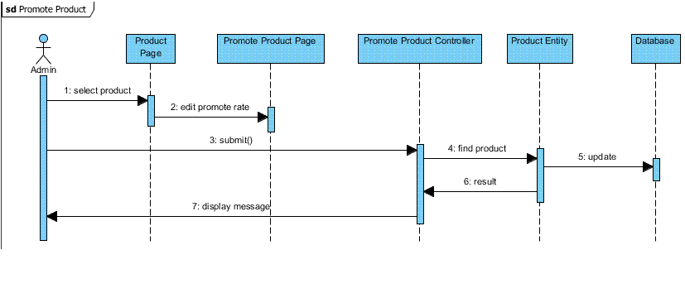

Figure 26.Promate Product Sequence

Author | Huynh Quoc Thanh
Use Case Name | Promote Product
Actor | Administrator
Description | Administrator can promote product such as: top, special, feature.
Requirements | N/A
Pre-conditions | Authenticated user
Post-conditions | Success: Product status will be set successfully.  Fail: Error Message
Basic flow | Actor action  1. Actor clicks “Promote Product” on the Product Management page and chooses product which want to promote.  3. Actor selects product promotion. | System responses  2. System navigates actor to promote product page.  4. System updates product promotion into database and send “Update successfully” message.
Alternative flow | Actor action  1. Actor clicks other link. | System responses  2. System navigates actor to appropriate page.
Exception | Actor action  N/A | System responses  N/A

- Add Product

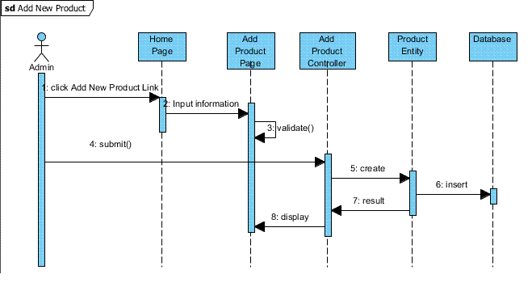

Figure 27.Add Product Sequence

Author | Huynh Quoc Thanh
Use Case Name | Add Product
Actor | Administrator
Description | Administrator wants to add new product in to system.
Requirements | N/A
Pre-conditions | Authenticated user
Post-conditions | Success: New Product will be add successfully  Fail: Error Message
Basic flow | Actor action  1. Actor clicks “Add Product” on the Product Management page.  3. Actor fills out all information and click “add” button. | System responses  2. System navigates actor to add product page and display “Edit Product” form with the following controls :  - “txtProName” text field  - “txtProDescription” text field  - “txtProPrice” text field  - “txtProQuantity” text field  - “btnUpload” upload images button  4. System validates information and Product will be added into database and send “Add successfully” message.
Alternative flow | Actor action  1. Actor clicks other link. | System responses  2. System navigates actor to appropriate page.
Exception | Actor action  N/A | System responses  N/A

- List Product

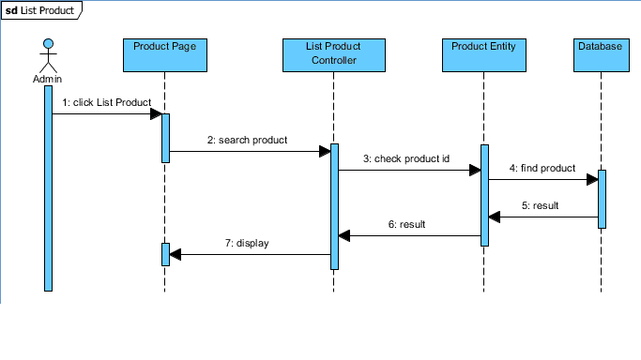

Figure 28.List Product Sequence

Author | Huynh Quoc Thanh
Use Case Name | List Product
Actor | Administrator
Description | Administrator views list of product
Requirements | N/A
Pre-conditions | Authenticated user
Post-conditions | Success: All product will be shown  Fail: Error Message
Basic flow | Actor action  1. Actor clicks “List product” on the main administrator page  3. Actor fill Product field if they want to search product and click “submit” buttion. | System responses  2. System navigates actor to view category page and display category table with the following column:  - “name” of item.  - “description” information of item  4. System displays result as form with grid that contains some control as:  - “Product Name” of item  - “Product Description” of item  - “Product Price” of item  - “Product images” of item
Alternative flow | Actor action  1. Actor clicks other link. | System responses  2. System navigates actor to appropriate page.
Exception | Actor action  1. Actor lefts required filed blank. | System responses  1. System displays error message.

- Edit Product
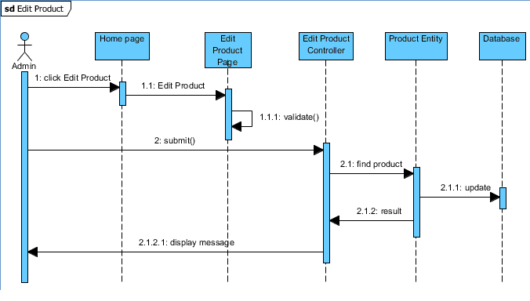

Figure 29.Edit Product Sequence

Author | Huynh Quoc Thanh
Use Case Name | Edit Product
Actor | Administrator
Description | Administrator edit exist product
Requirements | N/A
Pre-conditions | Authenticated user
Post-conditions | Success: Category will be update to system  Fail: Display error message
Basic flow | Actor action  1. After actor chooses product which will be edit, clicks “Edit” icon.  3. Actor edit information and click “Update” button | System responses  2. System navigates actor to edit category page and display “Edit Product” form with the following controls :  - “txtProName” text field  - “txtProDescription” text field  - “txtProPrice” text field  - “txtProQuantity” text field  - “btnUpload” upload images button  4. System validate information  5. Add data into database and send “Update successfully message”.
Alternative flow | Actor action  1. Actor clicks other link. | System responses  2. System navigates actor to appropriate page.
Exception | Actor action  1. Actor lefts required filed blank. | System responses  System displays error message.

- Manage Order

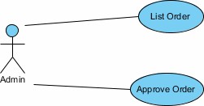

Figure 30.Manage Order Use case

- List order
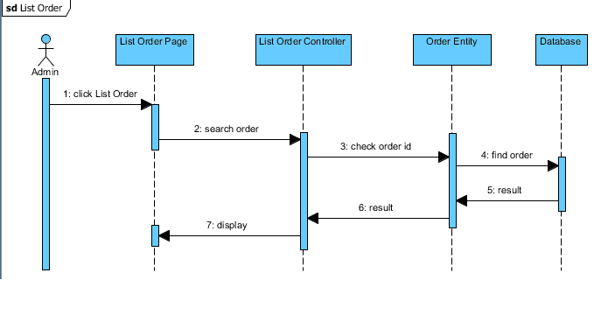

Figure 31.List Order Sequence

Author | Tang Vi Nguyen
Use Case Name | List Order
Actor | Administrator
Description | Administrator views Order List
Requirements | N/A
Pre-conditions | Authenticated user
Post-conditions | Success: All Customer’s order list will be shown
Basic flow | Actor action  1. Actor clicks “Manage order” on the main administrator page  3. Actor fills on customer name in text field to search order and click “filter” button. | System responses  2. System navigates actor to view order page and display order table with the following column:  - Customer name  - Order date  - Status  - Accept  - Sub Total  - Action  4. System displays result as form with grid that contains some control as:  - “Customer Name” of item  - “Order date” of item  - “Status” of item  - “Accept” of item  - “Sub total” of item  - “Action” of item
Alternative flow | Actor action  1. Actor clicks other link. | System responses  2. System navigates actor to appropriate page.
Exception | Actor action  1. Actor lefts required filed blank. | System responses  System redirects to page and displays error message.  1. Please fill all information.

- Approve Order

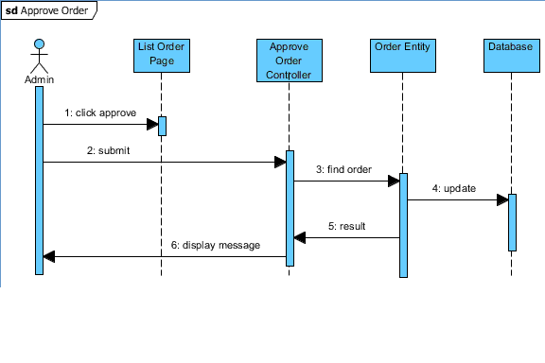

Figure 32.Approve Order Sequence

Author | Tang Vi Nguyen
Use Case Name | List Order
Actor | Administrator
Description | Administrator views Order List
Requirements | N/A
Pre-conditions | Authenticated user
Post-conditions | Success: All Customer’s order list will be shown
Basic flow | Actor action  1. Actor clicks “Manage order” on the main administrator page | System responses  2. System navigates actor to view order page and display order table with the following column:  - Customer name  - Order date  - Status  - Accept  - Sub Total  - Action  3. The actor changes product’s status thought list box which has three choice:  - “Queue”: accept this order and customers wait for shipping products.  - “Finish”: customers pay order and products were shipped.  - “Rejected”: this order was unvalued by actor.
Alternative flow | Actor action  1. Actor clicks other link. | System responses  2. System navigates actor to appropriate page.
Exception | Actor action  N/A | System responses  N/A

Entity and Entity Relationship diagram (ERD)

Entity Relationship diagram (ERD)

Category
Order Detail
Have
Have
Stock
N
1
N
Have

1
Order
Product
N
N
1
N
1
Have
Warehouse
Have
Factory
Have

Have

Shipment
Have

User
Membership
Have

Have

Country
Have

Role
Have

Dealer
1
1
1
1
1
1
1
1
1
1
N
N
N
N
N

Entity
User
Username
Password
Role id
Email
Phone
Address
Gender
Created
Country id

Dealer
Discount
Description
User id

Order
Order Date
Required Date
Shipment Date
Shipment Address
Total
Accepted flag
Status flag
IsRejected

Product
Name
Images
Prices
Description
IsSpecial
IsTop
IsFeature
IsFeature
Total Quantity
Category id
Warehouse id
Name
Name
Address
Factory id
Name
Address
Description
Description
Warehouse
Factory
Category

Review 2 Task Sheet

Group author: G.S4-E-02  Project title: Auto Ancillaries Limited |  |  | Assign tasks by:  Huynh Quoc Thanh
STT | Tasks | Start date | Complete date | Group member | Status
1 | Manage Guest Use Case – Sequence | 07/10/2010 | 07/10/2010 | Le Dang Minh | DONE
2 | Manage Dealer Use Case – Sequence | 07/10/2010 | 07/10/2010 | Le Dang Minh | DONE
3 | Manage Administrator Use Case – Sequence | 07/11/2010 | 07/11/2010 | Le Dang Minh | DONE
4 | Manage Category Use Case – Sequence | 07/11/2010 | 07/11/2010 | Le Dang Minh | DONE
5 | Manage Product Use Case – Sequence | 07/12/2010 | 07/12/2010 | Le Dang Minh | DONE
6 | Manage Discount Use case – Sequence | 07/12/2010 | 07/12/2010 | Le Dang Minh | DONE
7 | Manage Order Use Case - Sequence | 07/13/2010 | 07/13/2010 | Le Dang Minh | DONE
8 | Entity Relationship Diagram | 07/14/2010 | 07/16/2010 | Le Dang Minh | DONE
9 | Properties Of Entity | 07/17/2010 | 07/19/2010 | Le Dang Minh | DONE
10 | Guest functional description | 07/10/2010 | 07/11/2010 | Tang Vi Nguyen | DONE
11 | Dealer functional description | 07/11/2010 | 07/12/2010 | Tang Vi Nguyen | DONE
12 | Administrator functional description | 07/12/2010 | 07/13/2010 | Tang Vi Nguyen | DONE
13 | Category functional description | 07/13/2010 | 07/14/2010 | Tang Vi Nguyen | DONE
14 | Product functional description | 07/14/2010 | 07/15/2010 | Tang Vi Nguyen | DONE
15 | Discount functional description | 07/15/2010 | 07/15/2010 | Tang Vi Nguyen | DONE
16 | Order functional description | 07/15/2010 | 07/16/2010 | Tang Vi Nguyen | DONE
17 | Document preparation | 07/18/2010 | 07/19/2010 | Tang Vi Nguyen | DONE
18 | Coding Guest function | 07/10/2010 | 07/15/2010 | Huynh Quoc Thanh | DONE
19 | Coding Category Management function | 07/16/2010 | 07/19/2010 | Huynh Quoc Thanh | DONE

 | Prepared by (Student) | Approved by (Faculty)
Signature | Team leader | Nguyen Xuan Doan
Date | 19/7/2010 | 19/7/2010

Database Relationship Diagram
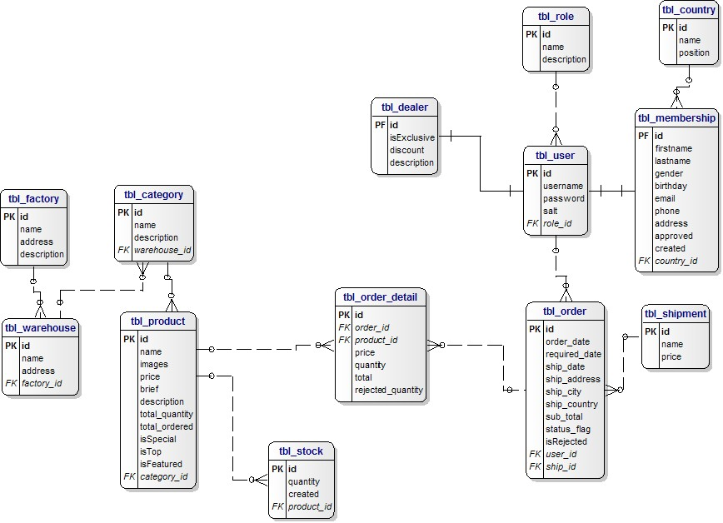

Figure 12.1.Database Relationship Diagram

Table Definition

- ‘tbl_role’ table stores users’ account role to login into system.

Tbl_user
Field name | Data type | Null | Default value | Table-ref field | Key | Description
Id | Int | NO |  | Tbl_role, tbl_membership, tbl_dealer, tbl_order, | PK | Identity(1, 1)
Username | Nvarchar(128) | NO
Password | Nvarchar(128) | NO
Salt | Nvarchar(128) | NO |  |  |  | Use for the encryption
Rold_id | int | YES

- ‘tbl_user’ table stores users’ login information and their role.

Tbl_role
Field name | Data type | Null | Default value | Table-ref field | Key | Description
Id | Int | NO |  |  | PK | Identity(1, 1)
Name | Nvarchar(128) | NO |  |  |  | Role name
description | Nvarchar(128) | YES |  |  |  | Role description

- ‘tbl_dealer’ table stores benefits’ dealer such as Exclusive and discount percent.

Tbl_dealer
Field name | Data type | Null | Default value | Table-ref field | Key | Description
Id | Int | NO |  |  | PK | Identity(1, 1)
isExclusive | tinyint | NO
Discount | Float | NO
description | Nvarchar(512) | NO

- ‘tbl_membership’ stores user personal information.

Tbl_membership
Field name | Data type | Null | Default value | Table-ref field | Key | Description
Id | Int | NO |  |  | PK | Identity(1, 1)
Firstname | Nvarchar(128) | NO
Lastname | Nvarchar(128) | NO
Gender | Tinyint | NO
Birhtday | datetime | NO
Email | Varchar(40) | NO
Phone | Varchar(40) | YES
Address | Nvarchar(512) | YES
Approved | Tinyint | NO |  |  |  | Lock or unlock user logins into system
Created | Datetime | NO |  |  |  | Created date
Country_id | int | YES |  | Tbl_country

- ‘tbl_country’ stores country information such as country name and position.

Tbl_country
Field name | Data type | Null | Default value | Table-ref field | Key | Description
Id | Int | NO |  |  | PK | Identity(1, 1)
Name | Nvarchar(40) | NO |  |  |  | Country’s name
position | int | YES |  |  |  | Country’s position

- ‘tbl_shipment’ stores type of shipment fee.

Tbl_shipment
Field name | Data type | Null | Default value | Table-ref field | Key | Description
Id | Int | NO |  |  | PK | Identity(1, 1)
Name | Nvarchar(128) | NO
price | money | YES

- ‘tbl_order’ stores customers’ order information about: order date, ship date, address, city, country, order price, order’s status.

Tbl_order
Field name | Data type | Null | Default value | Table-ref field | Key | Description
Id | Int | NO |  | Tbl_order_detail, tbl_shipment | PK | Identity(1, 1)
Order_date | Datetime | NO
Required_date | Datetime | NO
Ship_date | Datetime | NO
Ship_address | Nvarachar(128) | NO
Ship_city | Nvarachar(128) | NO
Ship_country | Nvarachar(128) | NO
Sub_total | Money | NO
Status_flag | tinyint | NO |  |  |  | Order’s status:  - 0 : pending  - 1 : queue  - 2 : cancel  - 3 : finish
isRejected | Tinyint | NO
User_id | Int | NO |  | Tbl_user
Ship_id | int | NO |  | Tbl_shipment

- ‘tbl_order_detal’ stores order details information include: product name, price , quantity.

Tbl_order_detail
Field name | Data type | Null | Default value | Table-ref field | Key | Description
Id | Int | NO |  |  | PK | Identity(1, 1)
Order_id | Int | NO |  | Tbl_order | FK
Product_id | Int | NO |  | Tbl_product | FK
Price | Money | NO
Quantity | Int | NO
Total | Money | NO
Rejected_quantity | Int | NO |  |  |  | Products were rejected by provider.

- ‘tbt_product’ stores product’s information such as : product name , description, images , price, total stock, status.

Tbl_product
Field name | Data type | Null | Default value | Table-ref field | Key | Description
Id | Int | NO |  | Tbl_order_detail | PK | Identity(1, 1)
Name | Varchar(128) | NO
Images | Varchar(512) | NO
Price | Money | NO
Brief | varachar(512) | NO |  |  |  | Short description
Description | Text | NO
Total_quantity | int | NO |  |  |  | Total stock
Total_ordered | int |  |  |  |  | Total orders by customers
isSpecial | Money | NO
isTop | tinyint | NO
isFeatured | Tinyint | NO
Category_id | Int | NO |  | Tbl_category | FK

- ‘tbl_category’ stores product classification

Tbl_category
Field name | Data type | Null | Default value | Table-ref field | Key | Description
Id | Int | NO |  |  | PK | Identity(1, 1)
Name | Varchar(128) | NO
Description | Text | YES
Warehouse_id | Int | YES |  | Tbl_warehouse | FK

- ‘tbl_stock’ stores total number of items produced

Tbl_stock
Field name | Data type | Null | Default value | Table-ref field | Key | Description
Id | Int | NO |  |  | PK | Identity(1, 1)
quantity | Int | NO
Created | Datetime | NO
Product_id | int | NO |  | Tbl_product | FK

- ‘tbl_warehouse’ stores warehouses’ information: name , address , under factory

Tbl_category
Field name | Data type | Null | Default value | Table-ref field | Key | Description
Id | Int | NO |  |  | PK | Identity(1, 1)
Name | Varchar(128) | NO
address | Varchar(256) | NO
factory_id | Int | NO |  | Tbl_factory | FK

- ‘tbl_factory’ stores factories information

Tbl_category
Field name | Data type | Null | Default value | Table-ref field | Key | Description
Id | Int | NO |  |  | PK | Identity(1, 1)
Name | Varchar(128) | NO
Address | Varchar(256) | NO
description | text | NO

GUI design
- General GUI
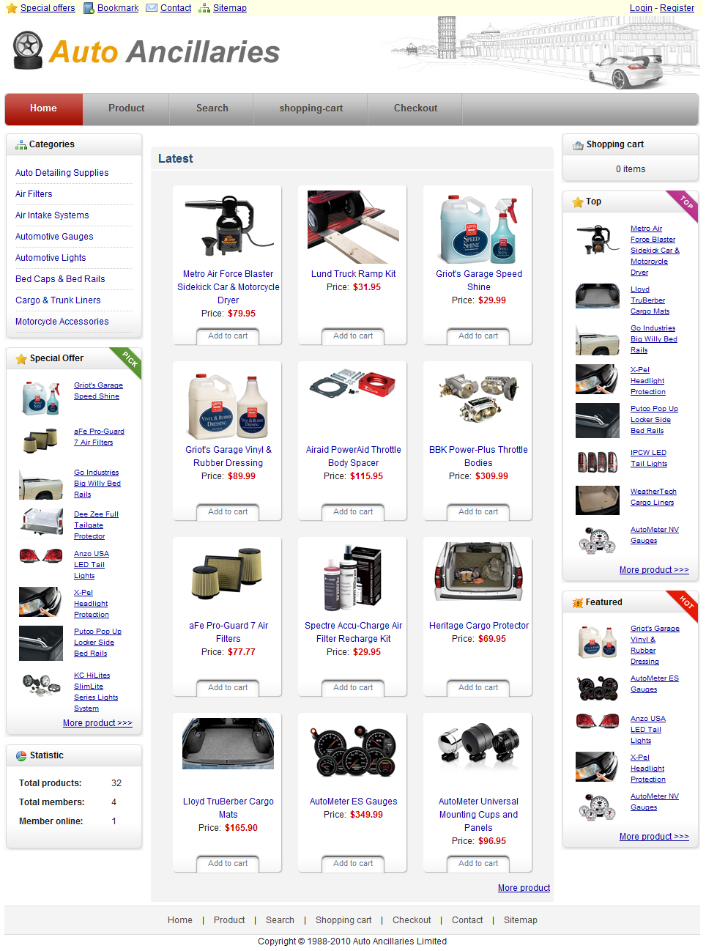

- Login page

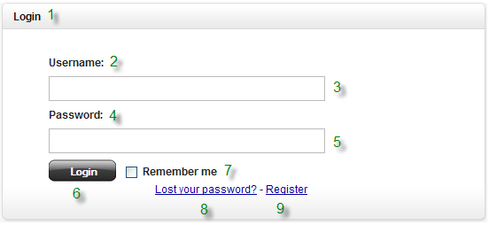

No. | Name | Type | Validation | Event | Description | Status
1 | lblLogin | Label |  |  | Title of login
2 | lblUsername | Label |  |  | Username label
3 | txtUsername | Textbox | required: true, rangelength: [6, 20] |  | Input username
4 | lblPassword | Label |  |  | Password label
5 | txtPassword | Textbox | required: true, rangelength: [6, 20] |  | Input password
6 | btnLogin | Button |  | Click | Login button
7 | chkRemember | Checkbox |  | Check | Remember username and password in next time
8 | lnkLostPassword | Link |  | Click | Redirect to Recovery password page
9 | lnkRegister | Link |  | Click | Redirect to register page

- Register page

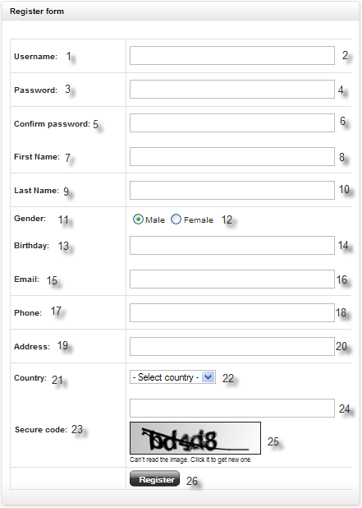

No. | Name | Type | Validation | Event | Description | Status
1 | Username | Label |  |  | Username label
2 | txtUsername | Textbox | required: true, rangelength: [6, 20], remote: ValidateUsername |  | Input username
3 | Password | Label |  |  | Password label
4 | txtPassword | Textbox | required: true, rangelength: [6, 20] |  | Input password
5 | Confirm Password | Label |  |  | Confirm password label
6 | txtConfirmPassword | Textbox | required: true, equalTo: "#txtPassword" |  | Input confirm password
7 | First name | Label |  |  | First name label
8 | txtFirstname | Textbox | required |  | Input first name
9 | Last name | Label |  |  | Last name label
10 | txtLastname | Textbox | required |  | Input last name
11 | Gender | Label |  |  | Gender label
12 | raGender | Radio |  |  | Gender radio
13 | Birthday | Label |  |  | Birthday label
14 | txtBirthday | Textbox | required: true, vietnamedate: “/[0-9]{1,2}-[0-9]{1,2}-[0-9]{2,4}$/” |  | Input birthday
15 | Email | Label |  |  | Email label
16 | txtEmail | Textbox | required: true, email: true |  | Input email
17 | Phone | Label |  |  | Phone label
18 | txtPhone | Textbox | required |  | Input phone
19 | Address | Label |  |  | Address label
20 | txtAddress | Textbox | required |  | Input address
21 | Country | Label |  |  | Country label
22 | cboCountry | Combo box | required |  | Select country
23 | Secure code | Label |  |  | Secure code label
24 | txtCaptcha | Textbox | required |  | Input captcha
25 | Captcha image | Image |  | Click | Captcha image
26 | btnRegister | Button |  | Click | Register button

- Member board

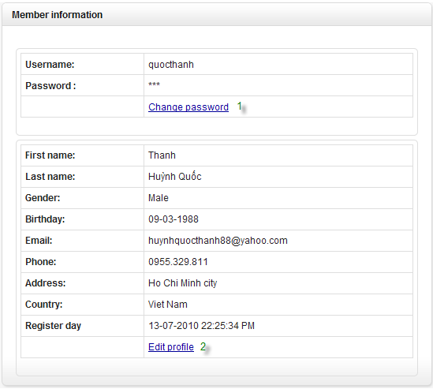

No. | Name | Type | Validation | Event | Description | Status
1 | Change password | Link |  | Click | Redirect to change password page
2 | Edit profile | Link |  | Click | Redirect to edit profile page
- Change password

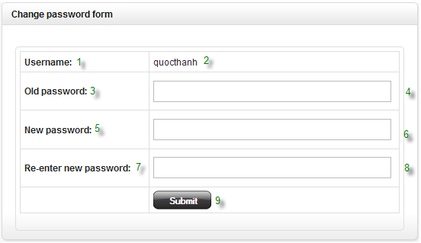

No. | Name | Type | Validation | Event | Description | Status
1 | Username | Label |  |  | Username label
2 | Quocthanh | Label |  |  | Display current username
3 | Old password | Label |  |  | Old password label
4 | txtOldPassword | Textbox | required: true, rangelength: [6,12] |  | Input old password
5 | New password | Label |  |  | New password label
6 | txtNewPassword | Textbox | required: true, rangelength: [6,12] |  | Input new password
7 | Confirm new password | Label |  |  | Confirm new password label
8 | txtConfirmNewPassword | Textbox | required: true, equalTo: "#txtNewPassword" |  | Input confirm new password
9 | btnLogin | Button |  | Click | Submit form to server

- Edit profile

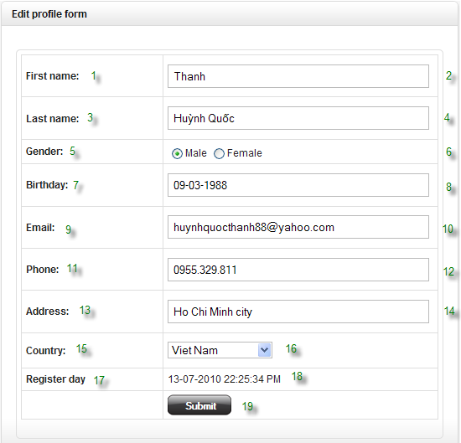

No. | Name | Type | Validation | Event | Description | Status
1 | First name | Label |  |  | First name label
2 | txtFirstname | Textbox | required |  | Input first name
3 | Last name | Label |  |  | Last name label
4 | txtLastname | Textbox | required |  | Input last name
5 | Gender | Label |  |  | Gender label
6 | raGender | Radio |  |  | Gender radio
7 | Birthday | Label |  |  | Birthday label
8 | txtBirthday | Textbox | required: true, vietnamedate: “/[0-9]{1,2}-[0-9]{1,2}-[0-9]{2,4}$/” |  | Input birthday
9 | Email | Label |  |  | Email label
10 | txtEmail | Textbox | required: true, email: true |  | Input email
11 | Phone | Label |  |  | Phone label
12 | txtPhone | Textbox | required |  | Input phone
13 | Address | Label |  |  | Address label
14 | txtAddress | Textbox | required |  | Input address
15 | Country | Label |  |  | Country label
16 | cboCountry | Combo box | required |  | Select country
17 | Register day | Label |  |  | Register day label
18 | Date time | Label |  |  | Display registered date
19 | btnChange | Button |  | Click | Submit profile to server

- Recovery password

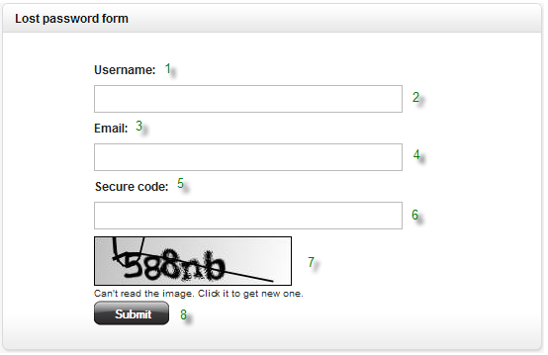

No. | Name | Type | Validation | Event | Description | Status
1 | Username | Label |  |  | Username label
2 | txtUsername | Textbox |  |  | Input username
3 | Email | Label |  |  | Email label
4 | txtEmail | Textbox |  |  | Input email
5 | Secure code | Label |  |  | Secure code label
6 | txtCaptcha | Textbox |  |  | Input captcha code
7 | Captcha image | Image |  | Click | Captcha image
8 | btnRecoveryPassword | Button |  | Click | Submit form to server

- Search page

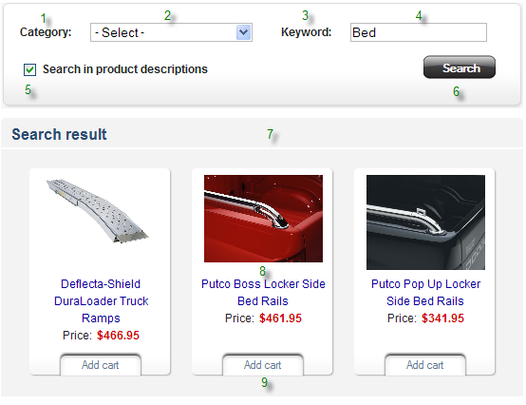

No. | Name | Type | Validation | Event | Description | Status
1 | Category | Label |  |  | Category label
2 | cboCategory | Combo box |  |  | Category dropdown list
3 | Keyword | Label |  |  | Keyword label
4 | txtKeyword | Textbox | Required |  | Input keyword
5 | chkDescription | Checkbox |  |  | Search in product description
6 | btnSearch | Button |  | Click | Perform search action
7 | Result grid | Grid |  |  | Display search result
8 | Product name | Link |  | Click | Redirect to product detail
9 | Add to cart | Button |  | Click | Add specific product into shopping cart

- Product details



No. | Name | Type | Validation | Event | Description | Status
1 | Product Title | Label |  |  | Product title
2 | $ | Label |  |  | Product price
3 | In stock | Label |  |  | Stock status
4 | Category | Link |  | Click | Redirect to category
5 | txtQuantity | Textbox | required: true, digits: true |  | Input order quantity
6 | btnAddToCart | Button |  | Click | Add specific product into shopping cart
7 | Cover image | Image |  | Click | Click to enlarge cover image
8 | Additional images | Image |  | Click | Click to view image gallery

- Administrator GUI
- General GUI
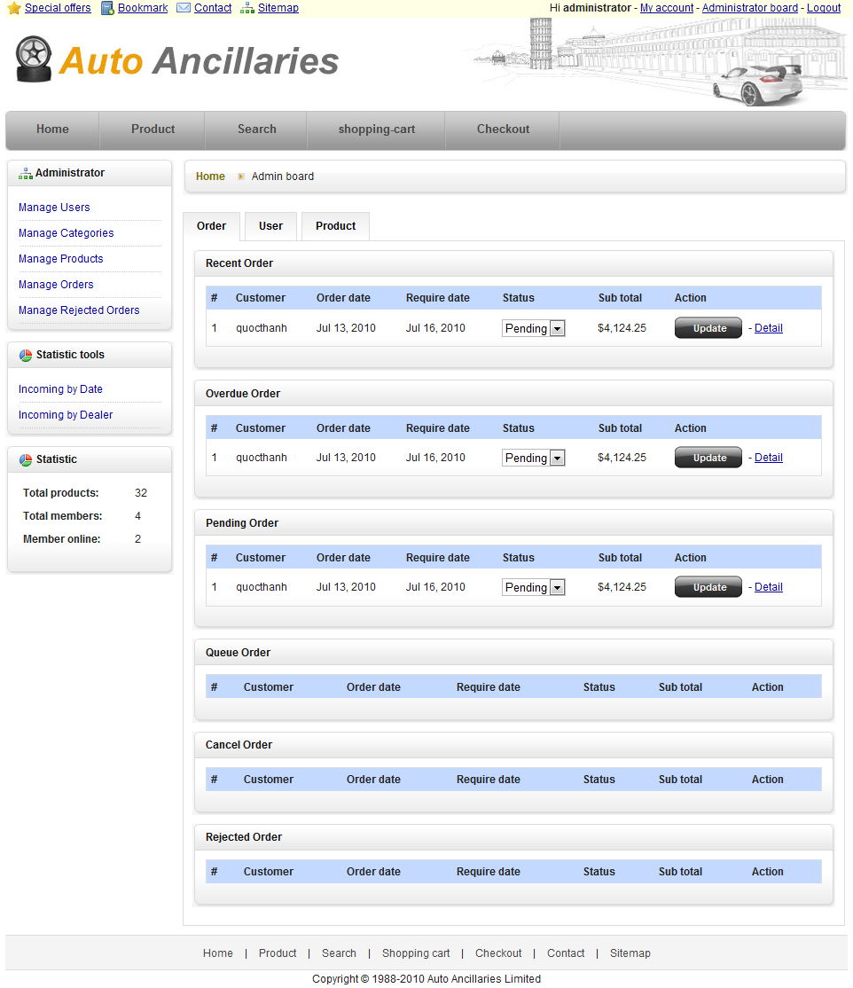

- User management general GUI

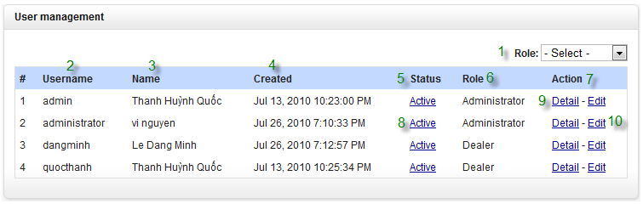

No. | Name | Type | Validation | Event | Description | Status
1 | cboRole | Combo box |  | select | Select role
2 | lblUsername | Label |  |  | Username label
3 | lblName | Label |  |  | User’s name label
4 | lblCreated | Label |  |  | Created date label
5 | lblStatus | Label |  |  | User status label
6 | lblRole1 | Label |  |  | User role label
7 | lblAction | Label
8 | Active | Link |  | Click | Inactive or Active users account.
9 | Detail | Link |  | Click | Viewing user details
10 | Edit | Link |  | Click | Edit user information

- User detail GUI

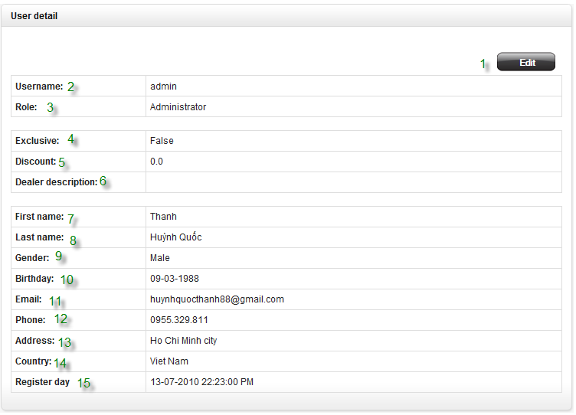

No. | Name | Type | Validation | Event | Description | Status
1 | btnEdit | Button |  | Click | Edit user information
2 | lblUsername | Label |  |  | Username label
3 | lblRole | Label |  |  | User role label
4 | lblExclusive | Label |  |  | Exclusive status
5 | lblDiscount | Label |  |  | Discount’s percent
6 | lblDescription | Label |  |  | User description
7 | lblFName | Label |  |  | User first name
8 | lblLName | Label |  |  | User last name
9 | lblGender | Label |  |  | User gender
10 | lblBrithday | Label |  |  | User birthday
11 | lblEmail | Label |  |  | User email
12 | lblPhone | Label |  |  | User phone
13 | lblAddress | Label |  |  | User address
14 | lblCountry | Label |  |  | User country
15 | lblRegiseDate | Label |  |  | User register day

- User detail GUI

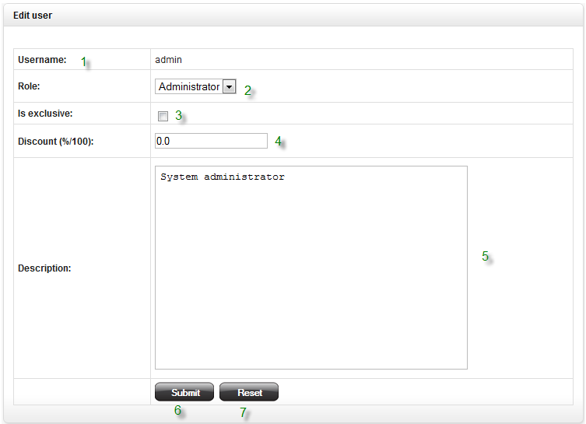

No. | Name | Type | Validation | Event | Description | Status
1 | lblUserName | Label |  |  | Username label
2 | cboRole | Combo box |  | Select | User role
3 | chkExclusive | Check box |  | Check | Exclusive checkbox
4 | txtDiscount | Text field | Required |  | Discount text field
5 | txtDescription | Text field | Required |  | Description text field
6 | btnSubmit | Button |  | Click | Submit button
7 | btnCancel | Button |  | Click | Cancel button

